1. Sales by Customer

<https://us1.ca.analytics.ibm.com/bi/?perspective=explore&pathRef=.my_folders%2FSales%2Bby%2Bcustomer&subView=model000001837d6eb849_00000004>

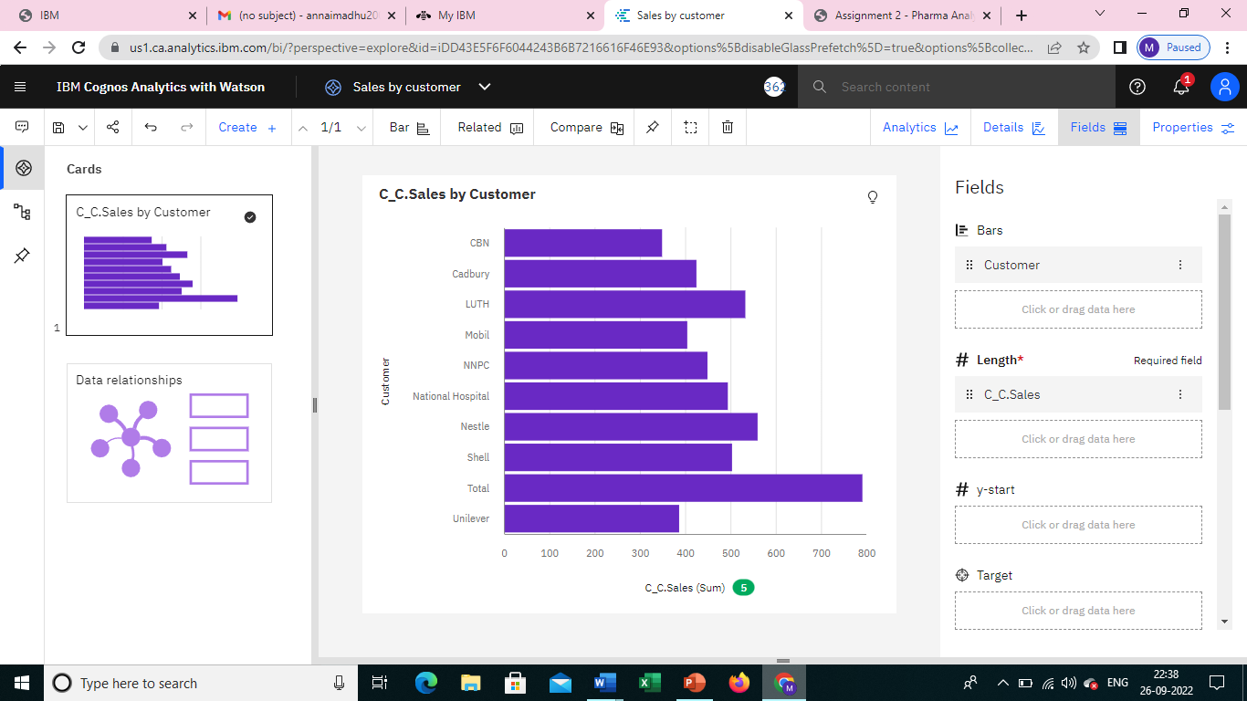

1. Sales by Location

<https://us1.ca.analytics.ibm.com/bi/?perspective=explore&pathRef=.my_folders%2FSales%2Bby%2Blocation&subView=model000001837d7494cb_00000002>

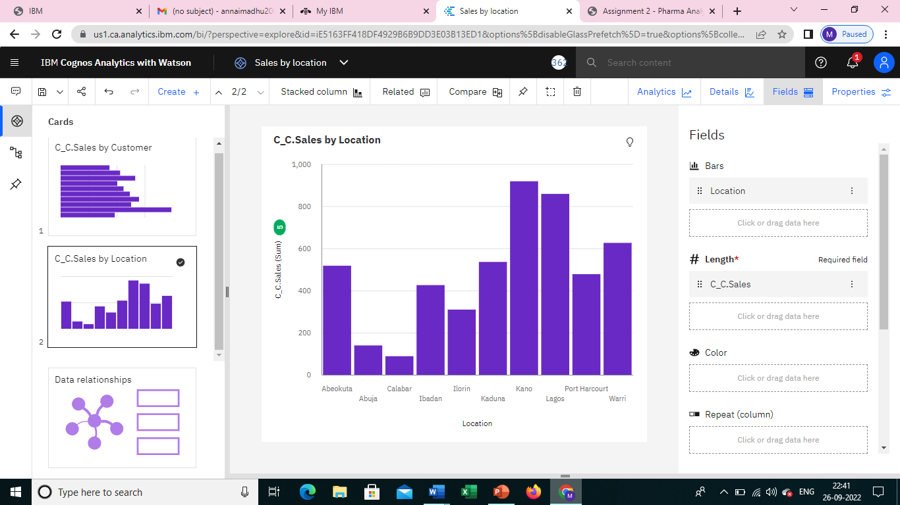

1. Sales by sales representative

<https://us1.ca.analytics.ibm.com/bi/?perspective=explore&pathRef=.my_folders%2FSales%2Bby%2Bsales%2Brep&subView=model000001837d7810a2_00000004>

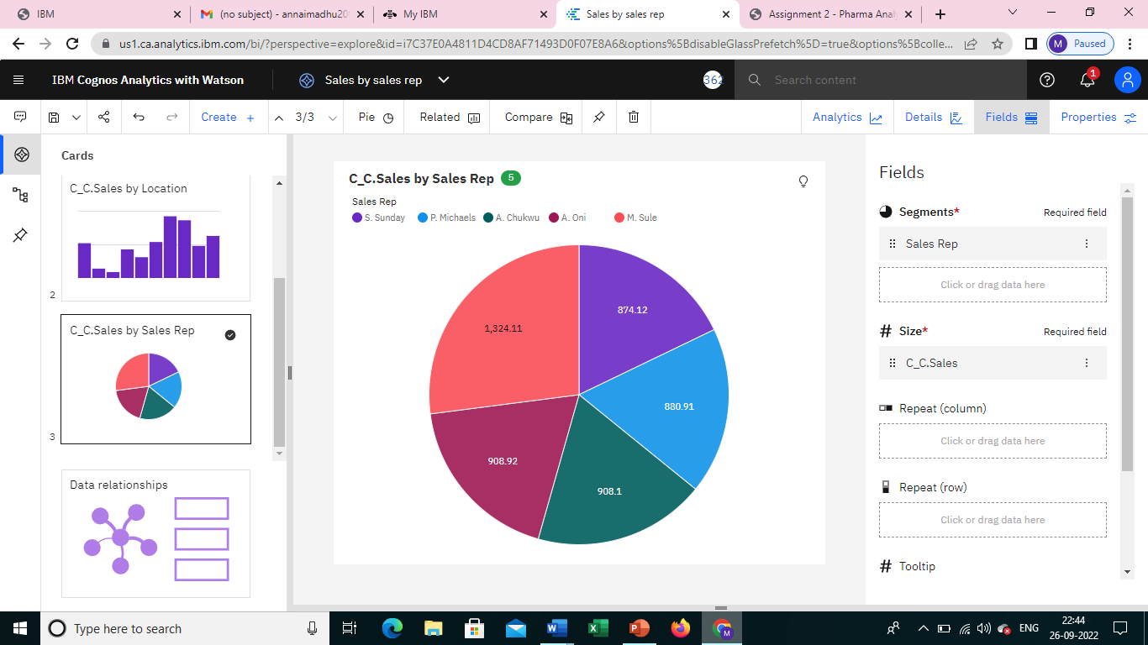

1. Received Inventory From Supplier

<https://us1.ca.analytics.ibm.com/bi/?perspective=explore&pathRef=.my_folders%2FReceived%2Binventory%2Bfrom%2Bsupplier&subView=model000001837d7a3189_00000000>

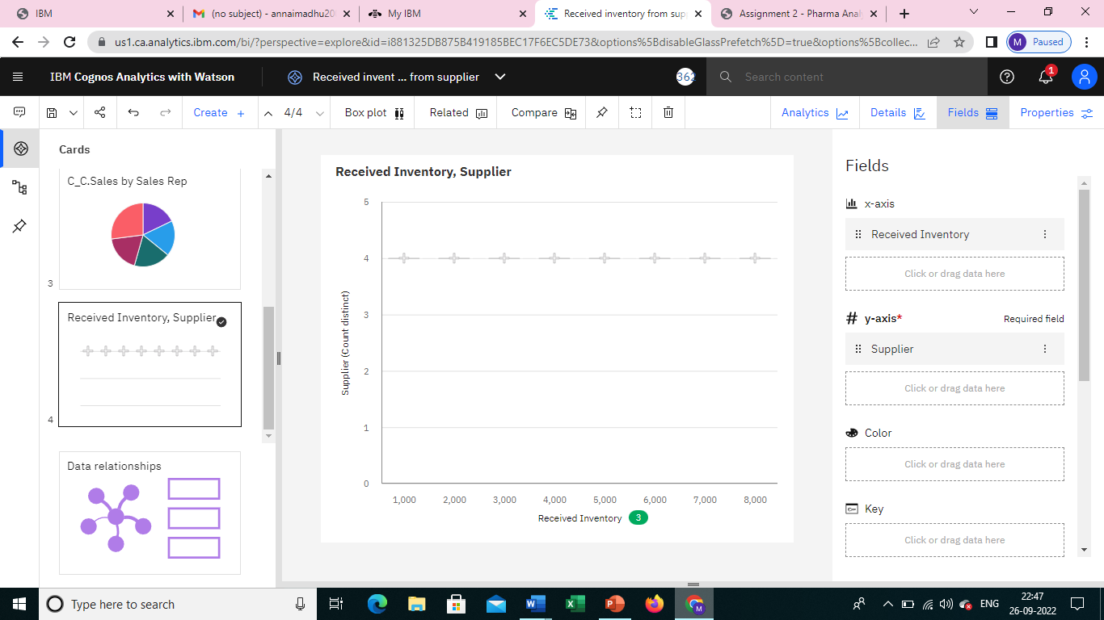

1. Inventory Stock for Warehouse Locations

<https://us1.ca.analytics.ibm.com/bi/?perspective=explore&pathRef=.my_folders%2FInventory%2Bstock%2Bfor%2Bwarehouse%2Blocations&subView=model000001837d7d5a31_00000000>

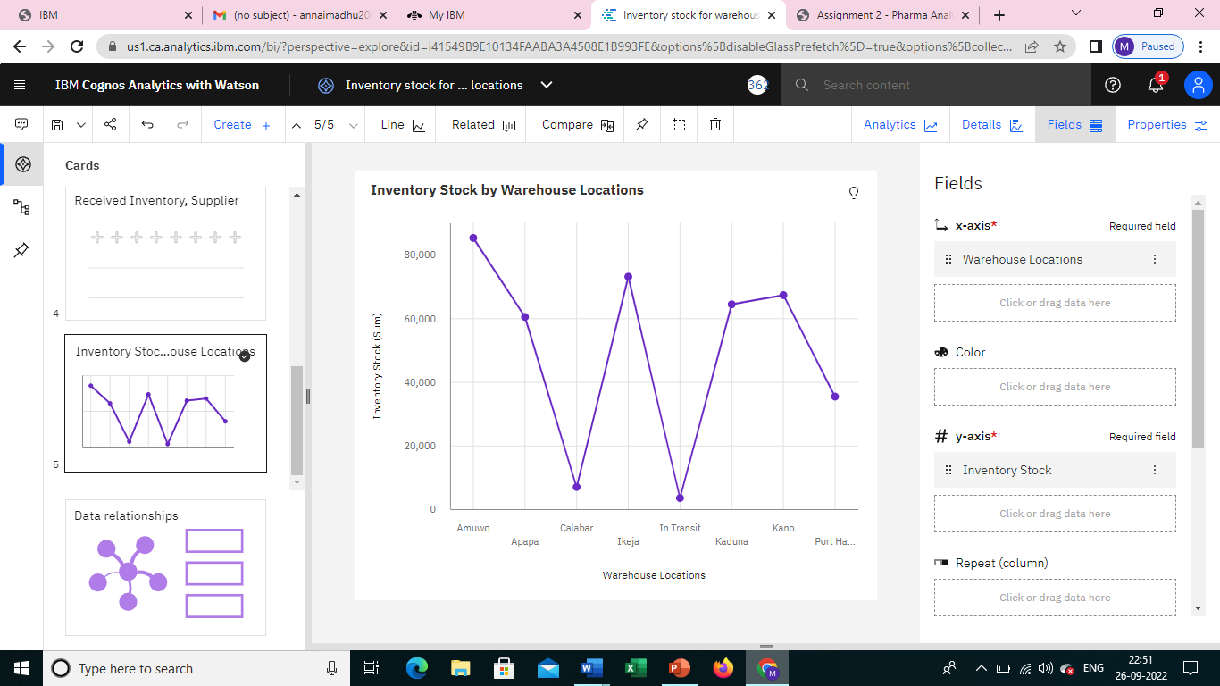

1. Sales Trend

<https://us1.ca.analytics.ibm.com/bi/?perspective=explore&pathRef=.my_folders%2FSales%2Btrend&subView=model000001837d80bf14_00000000>

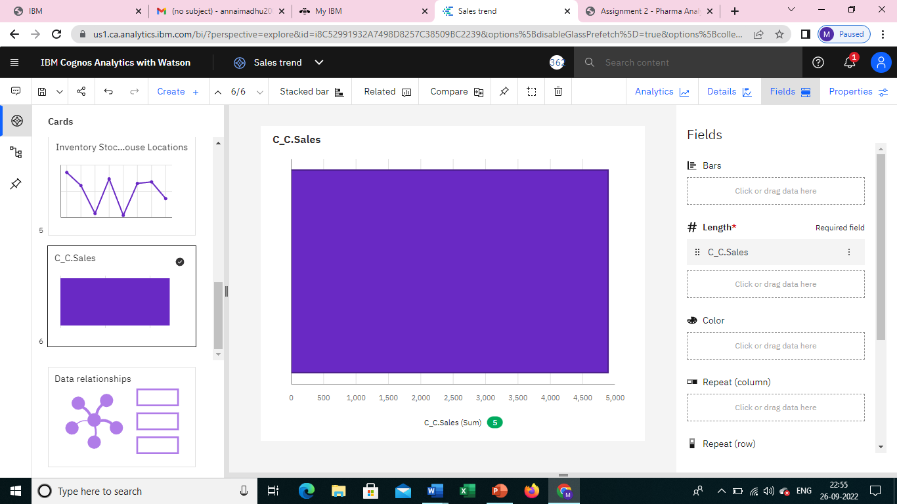

1. Monthly Sales

<https://us1.ca.analytics.ibm.com/bi/?perspective=explore&pathRef=.my_folders%2FMonthly%2Bsales&subView=model000001837d848ca3_00000004>

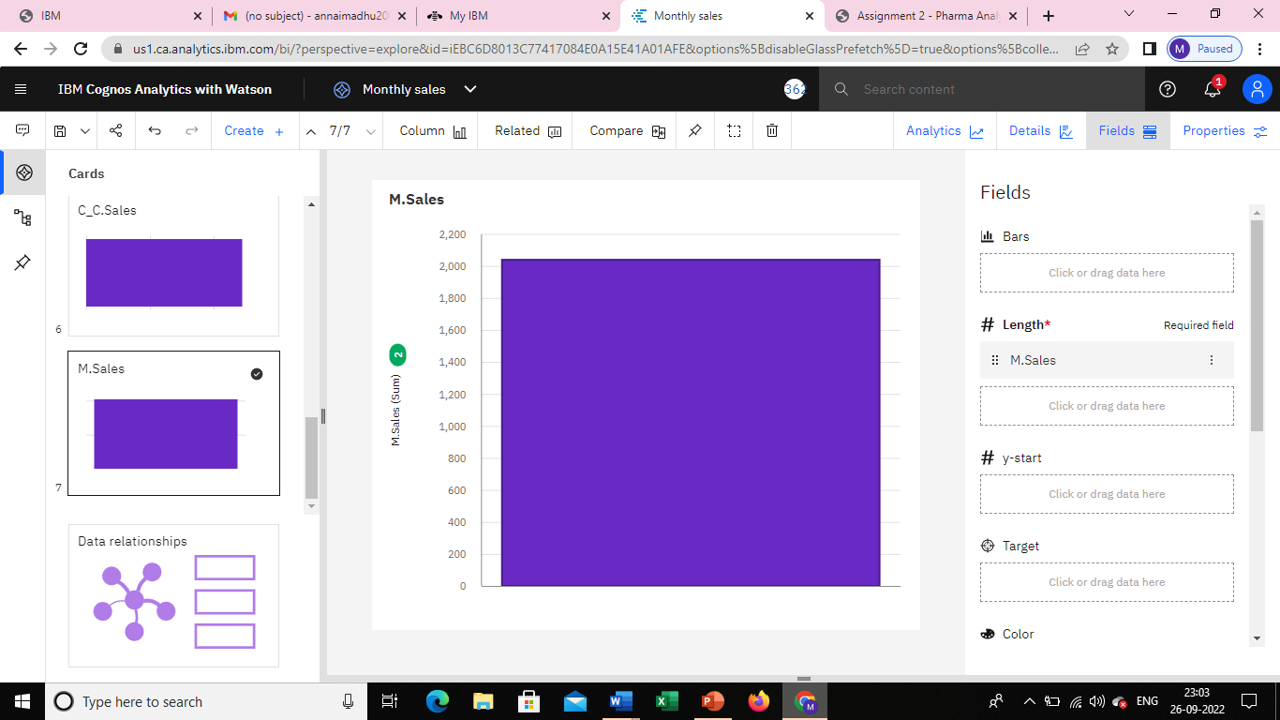

1. Actual and Received Inventory by Month

<https://us1.ca.analytics.ibm.com/bi/?perspective=explore&pathRef=.my_folders%2FActual%2Band%2Breceived%2Binventory%2Bby%2Bmonth&subView=model000001837d8bb6f1_00000000>

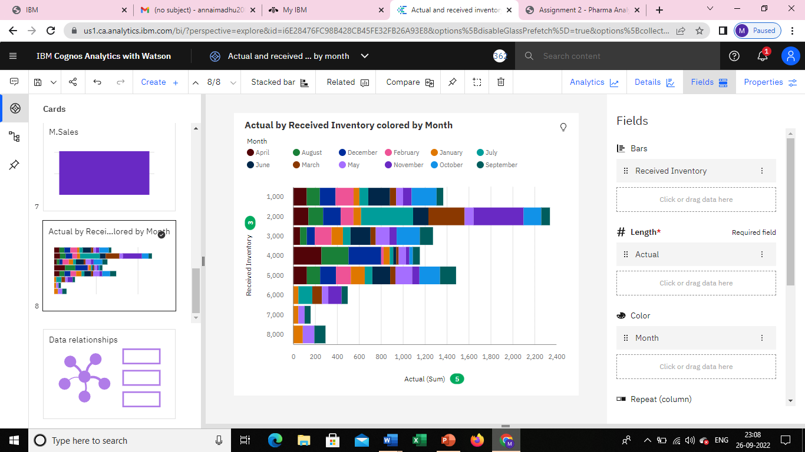

DASHBOARD

<https://us1.ca.analytics.ibm.com/bi/?perspective=dashboard&pathRef=.my_folders%2FNew%2Bdashboard&action=view&mode=dashboard&subView=model000001837d9085a8_00000000>

